Selling points:

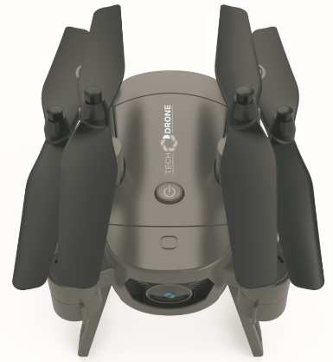
- Fast and dynamic drone that accelerates
up to 30 km/h.
- HD camera with tilt function (recording to mobile device directly for easy sharing)
- Live view from camera in smartphone and tablet (Android/iOS)
- The set includes 4 propellers and additionally 4 spare ones. 8 pcs. in total.
- The set includes 3 batteries, allowing the drone to fly up to 24 minutes
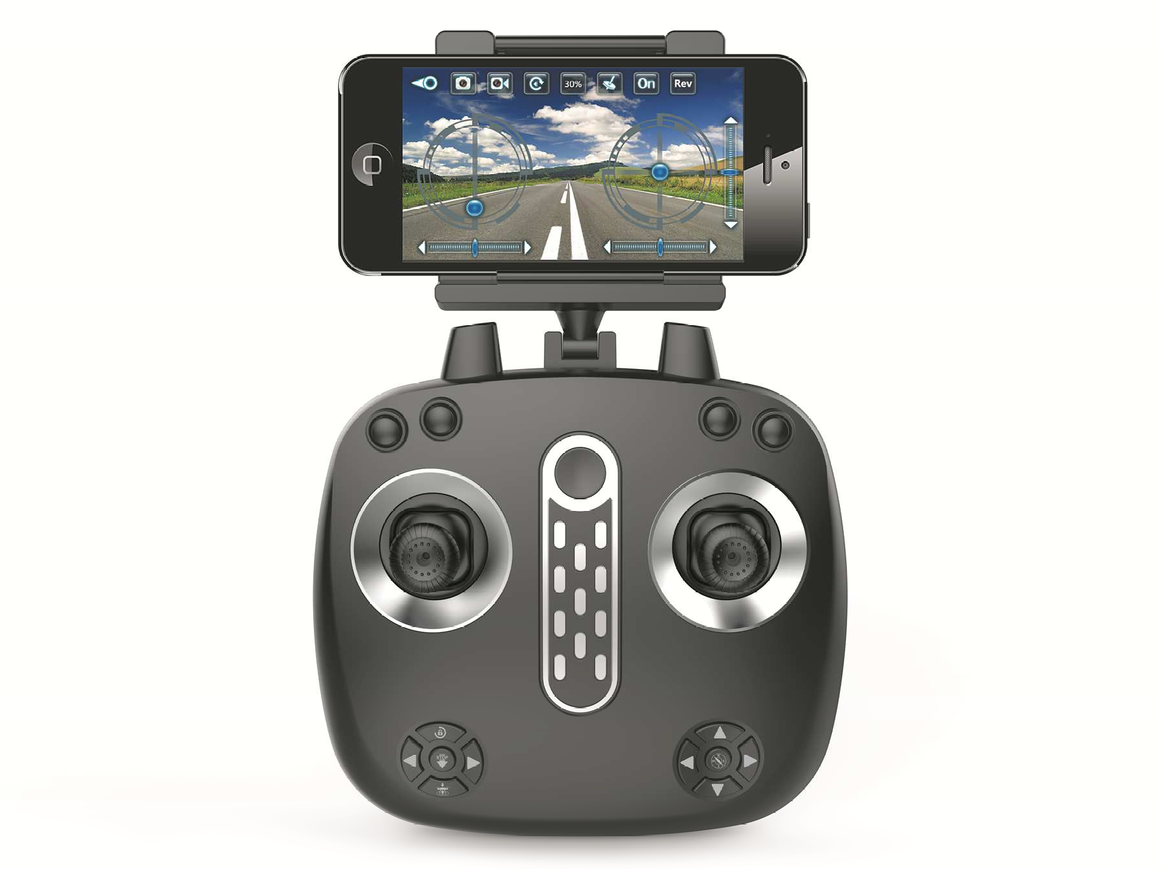
- Easy take foldable drone, Auto Hovering base barometer

Specification:

Camera: | HD camera with Wi-Fi antenna and mobile app support
FPV: | Live view on mobile device
Gyroscope: | 6-axis
Flight duration: | Up to 24 min.
Frequency: | 2,4 GHz (remote and Wi-Fi video signal)
Propellers: | 4 pcs (+4 spare ones)
Battery: | 3 x 850 mAh, Li-Po
Control range: | Up to 100 meters; up to 30 meters by APP
Charge Time: | Up to 90 min (of single battery)
Remote control: | 4CH remote control. 3 x AA 1,5V (batteries not included)
Illumination: | LED lights
Other: | 360° flip stunt, return to home button, headless mode, auto start, auto landing, emergency stop
Dimensions: | 32 cm x 28.5 cm x 12 cm
Accessories: | HD Wi-Fi FPV camera, battery charging cable, batteries, screw driver and screws, propeller’s protectors, propellers, remote with smartphone mount (5,5cm - 8,2cm smartphone’s width)

LOGISTIC DATA
Dimensions of unit box: 25.8 x 31.2 x 8.5 cm Dimensions of collective box: 52.7 x 63 x 70 cm Weight of collective box: 16 kg / 17.0 kg Number of pieces in collective box: 32 pcs

PRODUCT EAN: 5906736073354 PRODUCT CODE:

PRODUCER/PRODU
.

